SPARK Program Review Team
-2/4/2026 - team meeting

- Goal
  - Review our current specialty and signature programming

- How / with what tool(s) -- SUSD Quality Indicators to identify areas of strength, opportunities for growth and ways we can further support program implementation at school sites

- Progress update target -- Team read-out at March SPARK meeting
  - Provide an overview of each program listed below at our March whole group meeting

- To get to March read-out
  - Review the Quality Indicators
  - Determine which people will pair up for reviews
  - Co-create a consistent program review summary template that will become the way we provide annual updates on the progress of all programs

- Programs to be reviewed
  - International Baccalaureate
  - Math and Science Academy (MSA) at Saguaro and Mohave
  - STEAM Schools- Laguna and Navajo
  - AVID Programs
  - Traditional School Model
  - Dual Language Immersion

Agenda:

- Welcome and team connection
- Review of Quality Indicators and Programming Rubric
- Sharing of Resources
- Pair up for review

------------------------------------

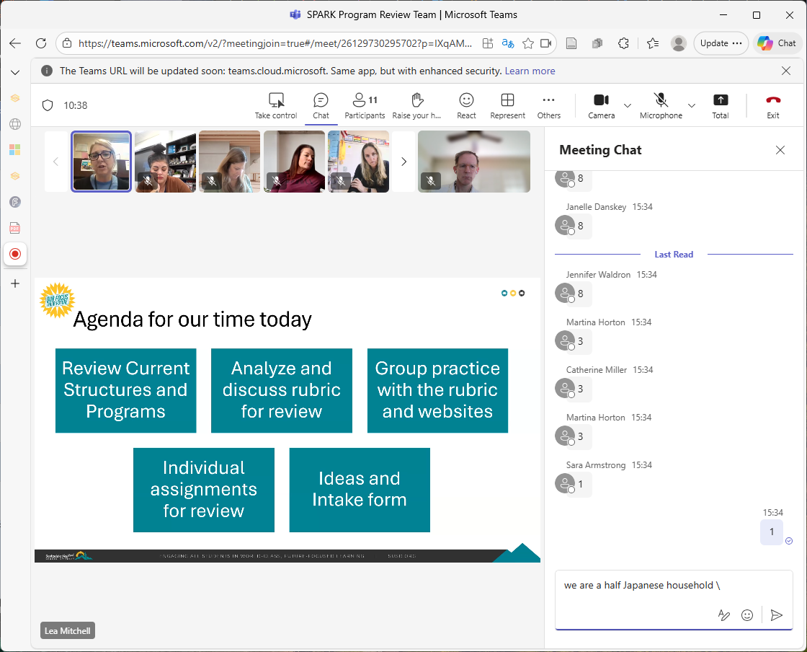

-also can think about the arts hub and gifted hub reviews as tied in part to the fact that schools closing translates to available space if the sites are repurposed

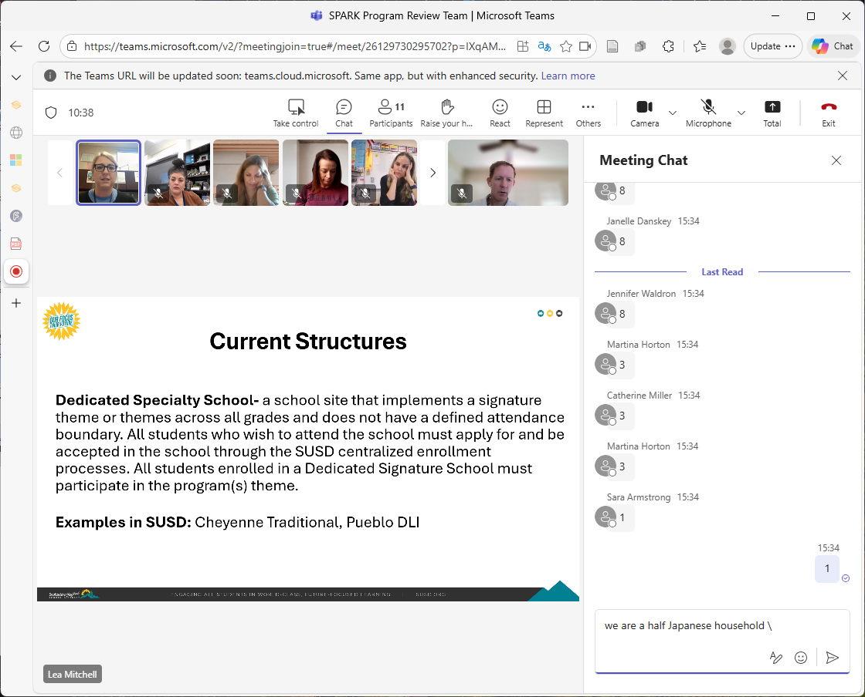

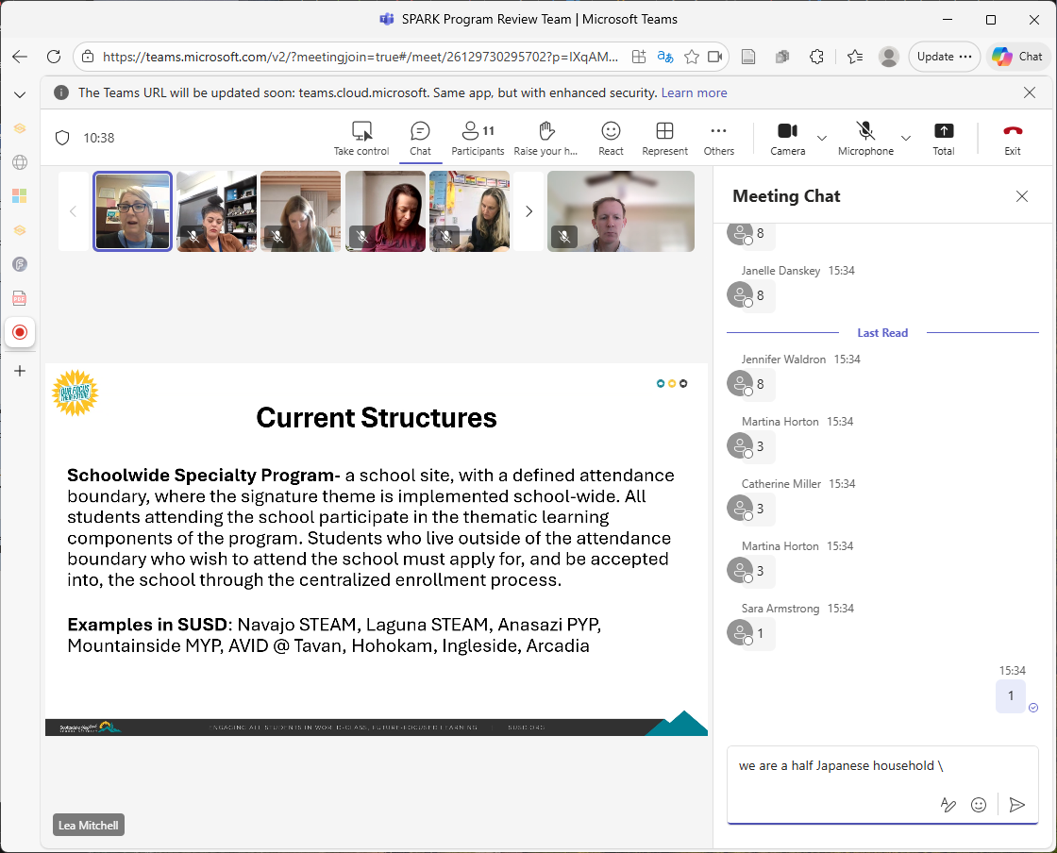

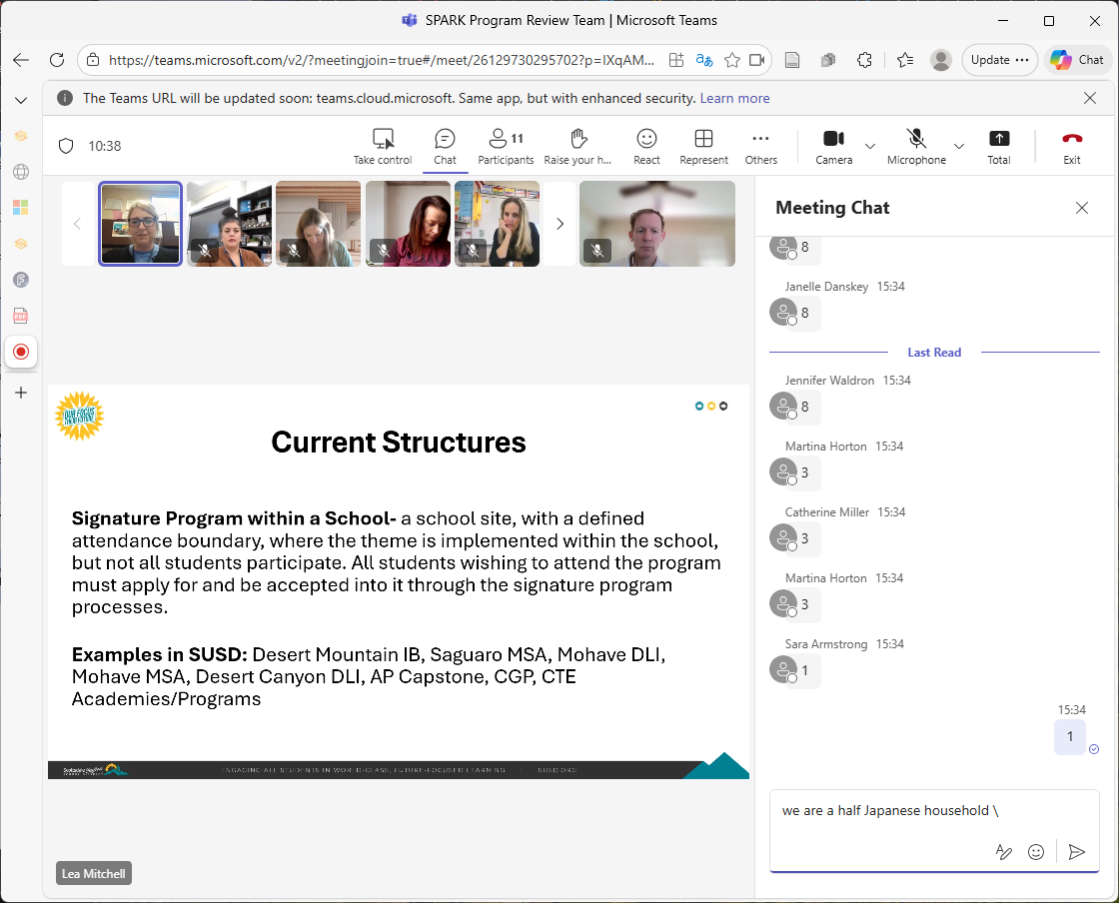

-need to add the structure / category dimensions to the workbook as appropriate

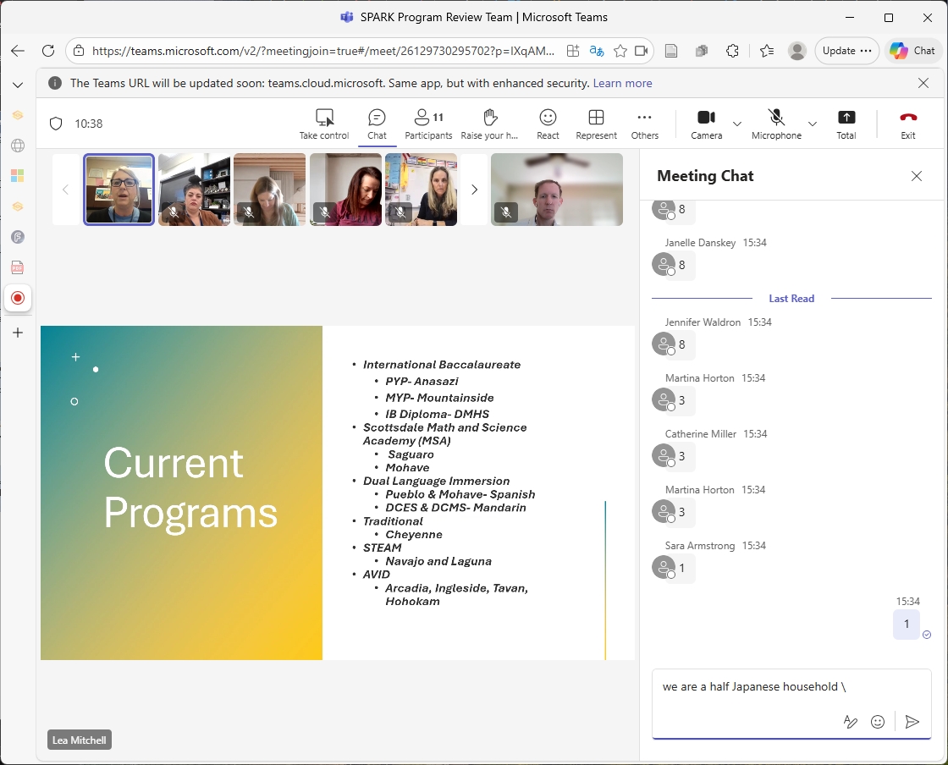

-*IB - there is already a IB-related program review in place… every x years…
--Anasazi was called out in IB world
--IB teachers get special training
--can enter at any points

-xx

-----------------------------

-intake concept
--What are the different input sources? Formal / informal… --
--Is there a common way we can receive or capture them and link them to SPARK for consideration? -- tied to the quality indicators, but a light weight version -- these might be 'submitted' or completed by spark persons?
--Is there then a preliminary triage that might be useful -- also light weight - where the outcomes might be to move to full review once full proposal received.. Request for clarifying information… keep on the radar for later… etc.
--Is there any cadence on this… tied to when SPARK might be able to review and evaluate, etc.?
--tying to ms. Mitchell's color-coded / heat map thought -- This might also translate to a dashboard of candidate ideas where we see sort of a heat map by maybe program category / need / interest area or grade level or other segments… and we can see where they are in the SPARK

-that is kind of the outside-in view… then maybe this can tie to an inside-out view -- meaning maybe
--This dashboard of programs… and candidate ideas might then also tie to need / opportunity dimensions that come out of a periodic landscape assessment… e.g. landscape / trends scan; understanding why students / families are entering.. Or exiting.. Etc.

-also can be an opportunity for engagement
-also can provide a standard way to e.g. respond to emails with new ideas -- e.g. where to go, where to submit.. Or where to review what already exists out there

------

-sequencing
--depends on stage
-evidence
--some core; some program-specific

-maybe both sequencing and evidence… and depth depend on what stage or module -- e.g. if it is a program review.. Or if it is a new program evaluation… in steady state for program review you might start with data and evaluation… for a new program candidate you might e.g. start in a sequence similar to the way it is laid out in the rubric…
…and then the ones we are doing now are sort of different?
-calibration of scoring

-also can act as a coaching / continuous improvement / opportunity identification -- might not use points scoring for existing programs.. Just to be careful
-future-proofed against certain risks… e.g. leadership / key staff succession planning. consider this by program as part of the program evaluation

-----------

